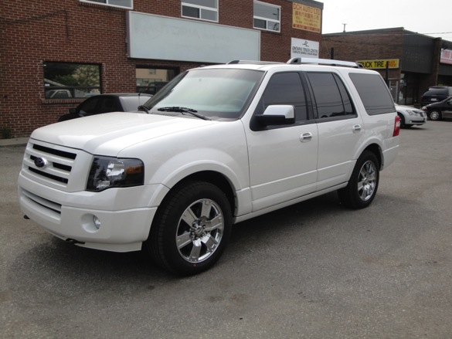
B6 Ford Expedition Armored Past Third Row; Was shipped to Nigeria
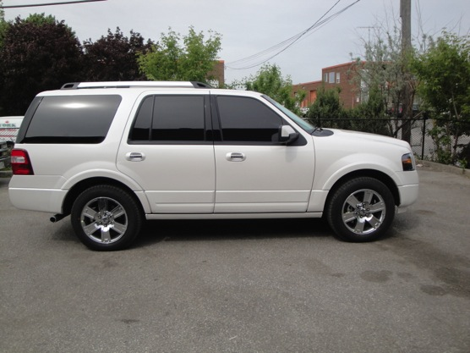
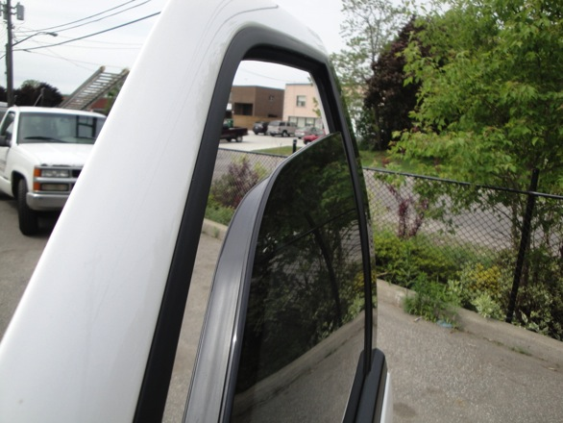

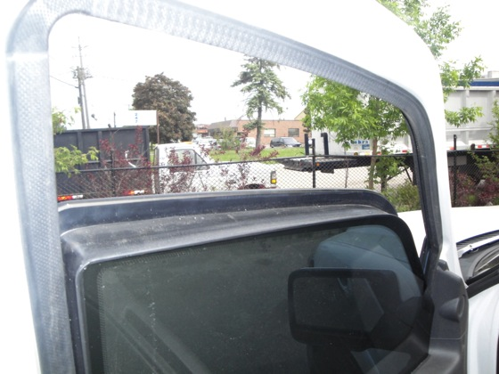

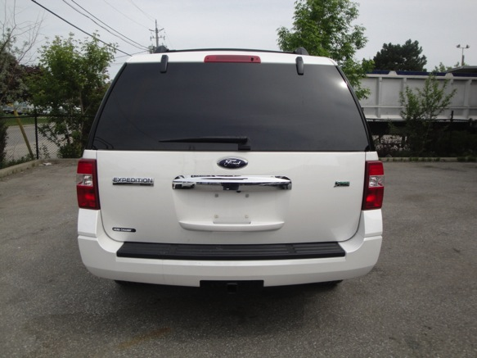
OEM Rear Door with Armored Barn Door System Behind
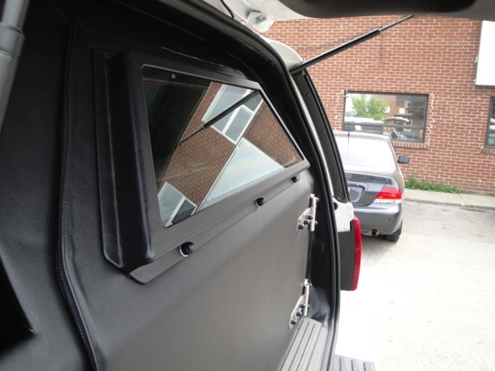
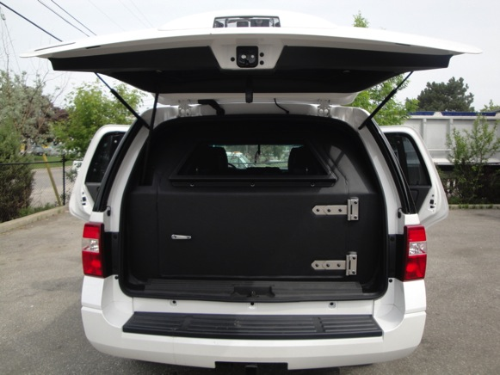
Armor Runs All the Way to Rear Doors Past 3rd Row Seats
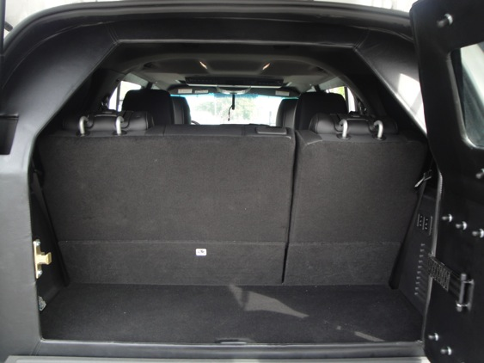
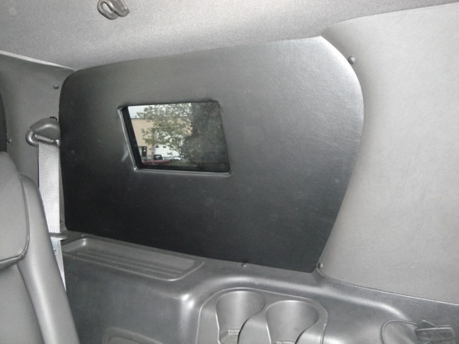
Smaller Ballistic Glass installed in internal module behind OEM Glass to help keep OEM appearance and reduce weight in Featherweight Package
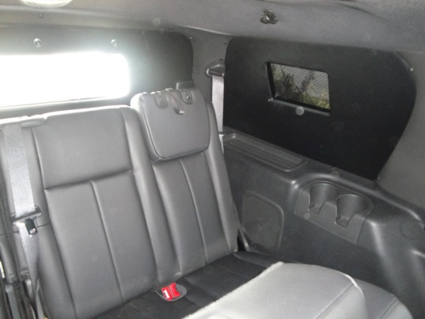

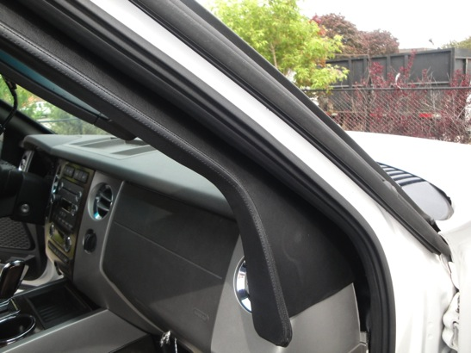
Armored Door Overlaps with Bullet Catches
Finished in material to match vehicle and done where very difficult to see from outside to keep OEM appearance of unit
